**10 unicorn companies you may want to keep an eye on for investment**

A unicorn company is a privately held start-up that has a valuation of more than $1 billions.

The number of unicorn companies are rising drastically in the recent years: from only 39 in 2013 to more than 1000 in March 2022.

Investing in unicorn companies may give you high returns, but is not straight-forward. Because average people like us cannot buy shares in most of these companies, unless they IPO.

However, we can follow the latest news of these companies regarding upcoming IPOs.

I analysed the [Unicorn Companies Dataset from Kaggle](https://www.kaggle.com/datasets/deepcontractor/unicorn-companies-dataset), with which I will present you answers to the following three questions:

1. Which countries have more unicorn companies?
2. What is the industry distribution of the unicorn companies? How is it different between United States and China?
3. Which 10 unicorn companies we may keep our eyes on for future investment?

**Question 1: Which countries have more unicorn companies?**

Figure 1. More than half of the unicorn companies originate from United States.

Companies from United States have dominated the markets for most years, so it’s not surprising to see United States have most unicorn companies.

China and India are sitting at the second and third place. UK, Germany, France and Israel also have many unicorn companies, where you may also want to invest some of your money.

**Question 2. What is the industry distribution of the unicorn companies? How is it different between United States and China?**

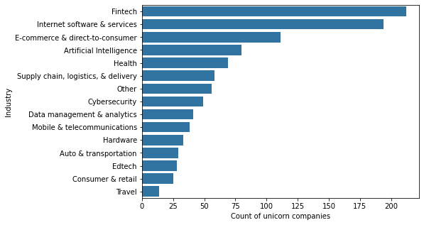Figure 2. Industry distribution of the unicorn companies

Fintech and Internet software & Services are the two industries with most unicorn companies.

As a Chinese, I wonder if this distribution is the same between US and China.

In the figure below, you can see that US has more unicorn companies within Internet software & services, Fintech, and cyber security industries.

On contrary, China has more unicorn companies within E-commerce & direct-to-consumer, Auto & transportation, and Hardware industries.

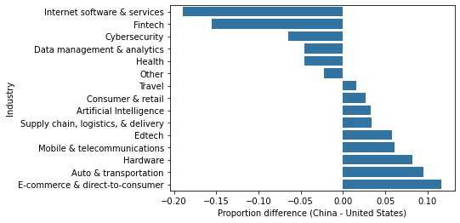Figure 3. Industry distribution difference between unicorn companies in China and in US.

**Question 3. Which 10 unicorn companies we may keep our eyes on for future investment?**

If you would like to invest in US or China, I have listed the ten highest valuable unicorn companies in these two countries below:

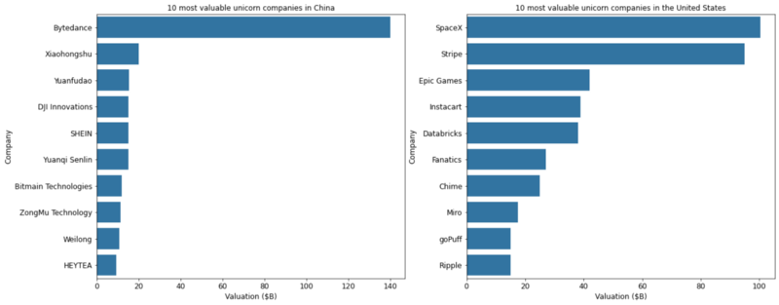Figure 4. 10 most valuable unicorn companies in China and US.

However, we want to diversify our investment. Therefore, I also listed 2 most valuable unicorn companies from India, United Kingdom, Germany, France and Israel respectively, as below.

In the end I have listed 30 most valuable unicorn companies from US, China, India, UK, Germany, France and Israel. Now it’s your turn to pick 10 out of this list!

Keep in mind that there may be fake unicorn companies and you should do your research.